Parth Babbar

Risk management operation

**Introduction:**

Risk management in banking is critical for maintaining financial health and stability in the United States financial system. It entails recognising, analysing, and reducing the many risks that banks face, such as credit risk, market risk, operational risk, liquidity risk, and regulatory risk. Effective risk management requires systematically identifying and assessing hazards, followed by strategic steps to mitigate their impact and maintain regulatory compliance. Banks may improve their resilience and integrity in volatile financial conditions by prioritising risk management procedures.

**Types of Risks:**

1. **Credit Risk:** It is the possibility that a borrower would fail to satisfy debt commitments by not making required payments. Credit rating systems, loan portfolio diversification, credit limit setting, and securitization procedures are some of the management measures used. As of 2023, non-performing loans (NPLs) in the United States banking sector amounted for around 1.0% of total loans, a significant decrease from the peak of 5.0% reported during the 2008 financial crisis.  
   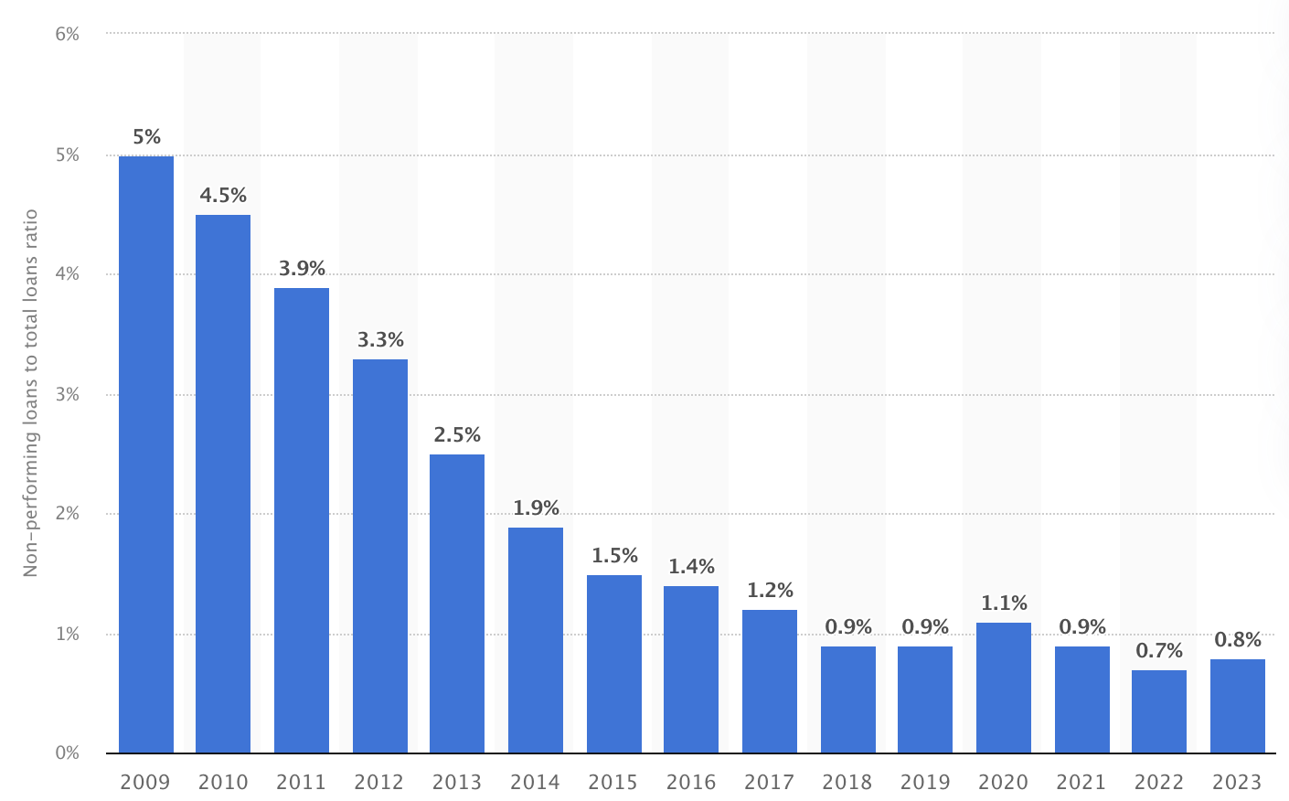
2. **Market Risk:** Market risk refers to possible losses resulting from market price changes in both on- and off-balance-sheet positions. Management techniques include Value-at-Risk (VaR) models, stress testing, and hedging measures. In Q1 2023, US banks' trading revenues, which represent market risk exposure, reached $7.5 billion, showing a steady trading environment. Maintaining financial stability and profitability in the face of market volatility requires effective market risk management.
3. **Operational Risk:** In banking, operational risk refers to the possibility for losses caused by internal process failures, people difficulties, system inadequacies, or external occurrences. It is handled with strong internal controls, audits, risk assessments, and incident response systems. Over the last five years, major US banks have averaged yearly operational losses of around $12.7 billion, highlighting the necessity of competent operational risk management in ensuring resilience and financial stability in the face of increasing problems.

**Regulatory Environment:**

1. **Basel III Framework**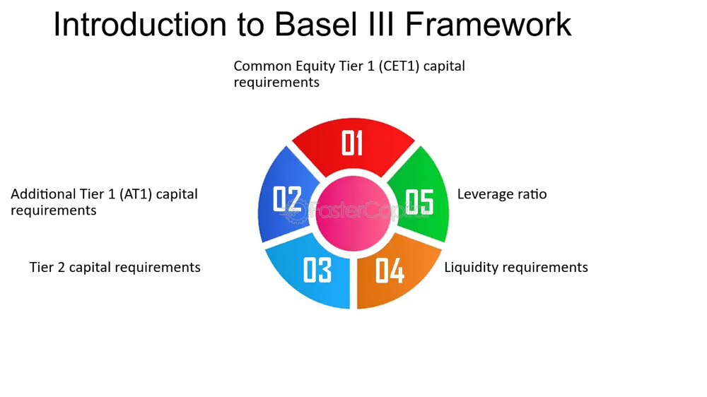
2. **Dodd-Frank Wall Street Reform and Consumer Protection Act**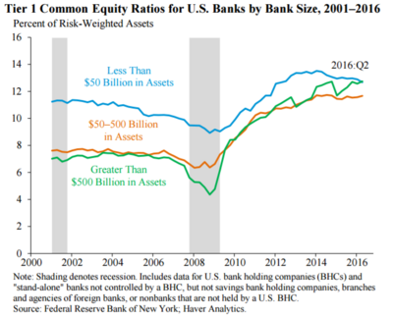
3. **Federal Reserve and FDIC Regulations**

**Risk Management:**

1. **Enterprise Risk Management (ERM)**
2. **Stress Testing**
3. **Risk Governance**
4. **Technology and Data Analytics**

**Conclusion:**

Effective risk management in US banking is critical to ensuring financial stability and preserving stakeholders' interests. Banks in the United States may better navigate the complicated and dynamic financial landscape by constantly developing their risk management strategies and remaining up to date on regulatory changes and new hazards.